[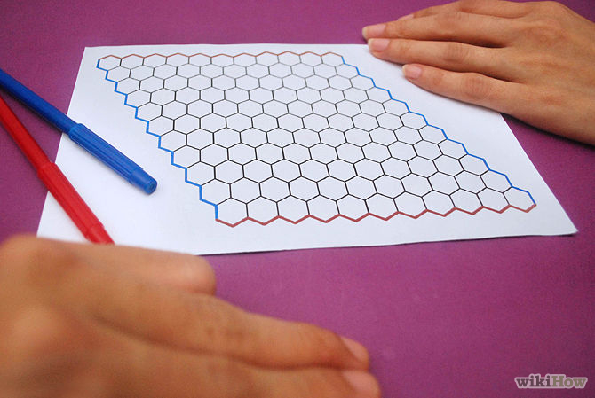](http://www.wikihow.com/Play-Hex#/Image:Play-Hex-Step-1.jpg)

**Begin with a board, two players, and a supply of pieces or markers in two different colors.** Each player chooses a color of markers and a pair of opposite sides which is shown here in red and blue.

Choose which player will go first

[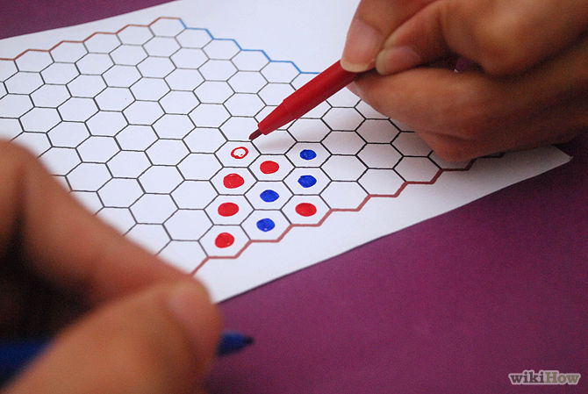](http://www.wikihow.com/Play-Hex#/Image:Play-Hex-Step-3.jpg)

Take turns’ placing one piece on the board per move.Once a piece is played, it stays there for the rest of the game. Either player may play a piece in any hexagon that is not yet occupied

[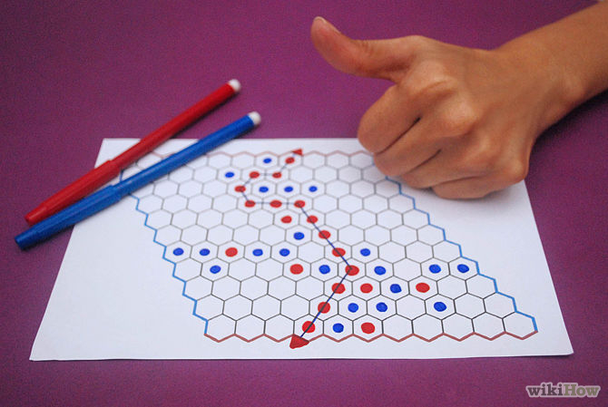](http://www.wikihow.com/Play-Hex#/Image:Play-Hex-Step-4.jpg)

Win by connecting a row of adjacent hexagons between your two opposite sides. Any continuous path will do and the pieces need not have to be placed in order. Here red has won.